Configuration: Standard lifetime
Source: 80 MHz B&H
Signal: CW from phone
Result:
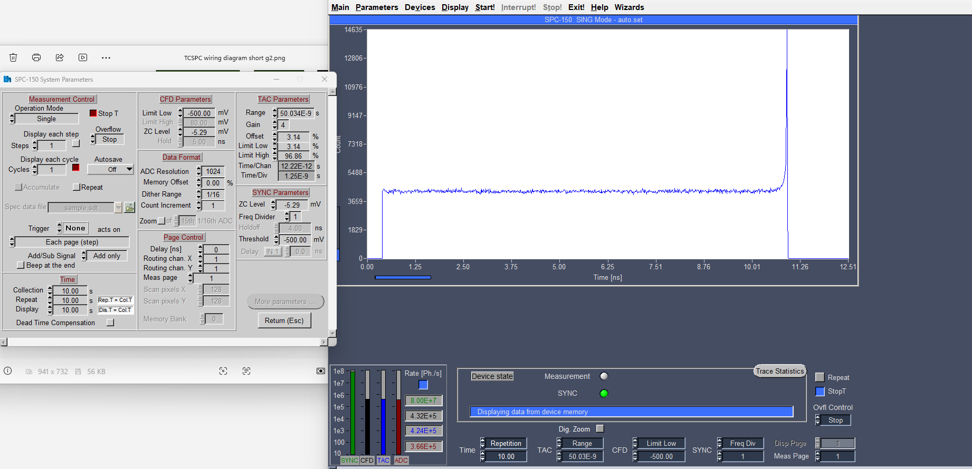

Configuration: Standard lifetime
Source: 80 MHz B&H
Signal: Weak PL
Result:

